© Copyright 2004 by John Menken

For additional copies, contact
Rockford Renewal Ministries
113 N. Wyman Street
Rockford, IL 61101

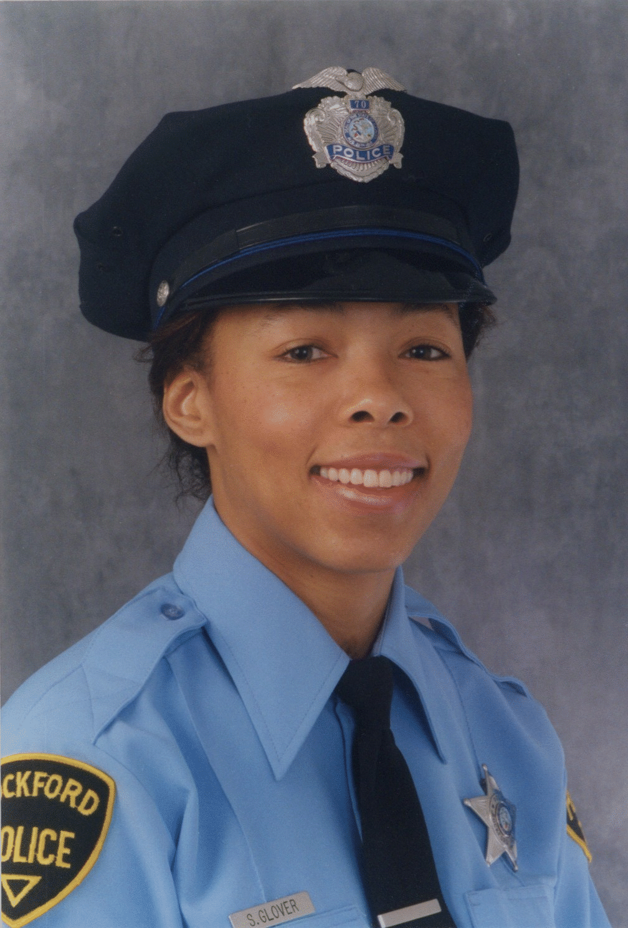
Officer Down!

Sheri Glover, Rockford, Illinois

Officer Down!

My life ended--and began--in the wee hours of April 14, 1993. I was an officer with the Rockford, Illinois Police department, on patrol that night in my squad car. About 2:15 a.m. I heard on my radio that Bob Verucci, a fellow officer, had made a traffic stop in a high crime area, a section of the city claimed by the Gangster Disciples. I went to back him up.

When I arrived, several other squad cars were already on the scene, so I stayed in my car to observe. Bob made an arrest and left the scene with his prisoner, and the other squad cars also left. Despite inner urgings to leave the area, I decided to stay and finish writing a report on a previous action. I was tough. My female intuition, police training, and street sense made me equal to any challenge. So I stayed and wrote my report.

I had grown up in church, with a godly mother who had provided love, security, and good spiritual training. I remember she often told me that if I'd say the Lord's Prayer, whatever I needed at that moment, God would faithfully provide. I knew that God loved me and wanted all of my life so He could work His will through me.

But at 15 years of age, I'd struck out in my own direction. I became independent of God. I kept Him around for convenience, picking and choosing those verses of the Bible I wanted to live by and ignoring the rest. At 28 years of age, I joined the police force, and, through the hardness of my work, I developed a callused heart as well. I had lost my normal, God-given sense of caution. I felt and believed myself to be invincible. I was my own person, and my inner strength would be sufficient for me.

Finishing my report at 2:30, I folded it and reached to place it above the right sun visor. The report never made it.

Four gunshots rang out. My trained mind went into slow motion, gathering in a multitude of details. The driver's side window of my squad car was broken. I felt some discomfort in my elbow and looked down to see if I was injured. My navy blue sweater revealed no blood. At that moment I did not know all four bullets had hit me: two in my forearm, one in my elbow, and one in my shoulder.

And then came a blow to the left side of my face, a blow forceful enough to throw me across the front seat of my car. A fifth gunshot had found its mark at the base of my left ear. The bullet bounced around inside my skull, destroying soft tissue, then exited my right cheek. My physical body shut down while my mind raced with instructions for self-preservation. "Shake your hands. Move your legs. Keep the blood flowing. Breathe!"

But it was no good. The instructions weren't getting through. I heard the noise of a waterfall. It was the rushing of blood through my ears. My mouth and nose were also choked with blood, and I knew I was suffocating. And then I died. I saw my soul vacate my body because it no longer had a safe place there. From outside myself, I looked at my own face and registered the thought, "Oh well, I'm dead."

I went to a very dark place, where I was aware of the presence of hundreds of thousands of sorrowful people--people I couldn't see, couldn't touch, couldn't comfort. I recognized the awful fact that I was forever separated from the love and power of almighty God, and was now helplessly exposed to tormenting spirits. There was no more chance for any of us there to ask forgiveness.

And then I was back in the squad car, and I heard a voice saying, "There is someone out there who is evil and mighty, but I am mightier." And I fell back upon mother's training, instead of my own strength. "Our Father, which art in heaven . . ." I began to pray in my mind. As I completed "hallowed be thy name . . . ", my airway cleared of blood and I felt an inrush of air. I was startled to hear my own voice and realized my lips were moving. By “ . . .thine is the kingdom, the power, and the glory forever,” I was able to radio in my own emergency call, though the dispatcher couldn't recognize my voice, and I could give no location.

Half a block away, officer John Eauclaire was in his squad car, still in the area from the 2:30 arrest. Hearing the gunshots and the emergency call, he remembered that there was still one squad car at the scene of the traffic stop when he'd pulled away. He thought to return to that location, and was first on the scene. I tried to tell him not to be afraid, because now I knew the Lord was with us. But all John could see was that I was breathing and mumbling something; I was still alive.

The police dispatcher had awakened the fire department at my first call, despite not knowing my location. Soon the street was swarming with squad cars, as officers rallied to help one of their own. In minutes the firemen arrived, and the ambulance a minute later. Though I should have been rejoicing in God's merciful intervention, I immediately returned to my old patterns and was again focusing all my own energies upon cooperating with the paramedic who was treating me.

With the street filled with patrolmen, detectives, and paramedics, it was easy to get caught up in the moment. There was a headiness about it all, a belief that we were going to make it turn out all right. After a fast ride to the hospital, I was surrounded by still more professionals, focused upon my care.

But soon it became apparent that all our combined human efforts wouldn't save me. My head began to swell from its injuries, and once again my breathing became blocked. The last thing I remember is grabbing my doctor's coat and crying, "I can't breathe!" My best friend waiting outside the treatment room says he heard me cry, "God help me, I can't breathe!" And again He did. I lost consciousness, and for seven minutes was clinically dead.

When I awoke two days later, I was giving praise to God. I had seen twice that I was powerless to sustain my own life. That was enough to convince me.

I would soon have to learn to depend upon God in other circumstances. The first night after my release from the hospital, I had a nightmare. I dreamed Satan was coming to rob my unsaved soul from God. I could see him coming toward me, and my fear was that I was his prey, helpless to resist. I couldn't save myself!

I awoke from that terror to see a mighty, bright angel at the foot of my bed. He said nothing, but I clearly heard his silent message. "You know why I am here." I watched as he glided from where he was, up to the side of my husband, who was lying beside me. I felt peace, and knew that resources greater than my own were at my disposal. And I went back to sleep. From that night I slept without nightmares--without dreams of any sort--for the next seven months.

Then came the trial. I was angry with my assailant, a known street person with a lengthy record and many other victims. I branded him a coward for sneaking up on me, depriving me a fair chance to defend myself. I was trained and prepared to meet confrontation, but he had snuck around my readiness.

Now, my anger was consuming me, eating away my insides, giving me ulcers. I wanted him put away, and I determined to do it myself, if necessary. One Sunday morning during the trial, I sat in church. With the service in progress, I was arguing with the Lord.

"God, put this man behind bars for the way he's hurt me and so many others, or I'll personally take his life." With my police training and experience, I knew how to do it. And though I was an emotional mess, I was still tough. I was able.
God answered my angry demand, "You do my will."
"But. . .!", I began.
"You do my will!" And this time I could physically feel someone poking me in the chest.
"But. . .", I objected once more.
"You do my will!"

I was powerless to forgive. I couldn't muster it. All I could do was cry out to God and release my anger to Him. When I did so, I received His supernatural power to forgive. Just then, our pastor was singing "Amazing Grace, how sweet the sound, that saved a wretch like me."

I began to understand down on the inside that I was that wretch, as guilty as anyone. The 17 years that I had lived rejecting God and His will made me as deserving of destruction as my assailant. There in church, I wept openly as the dam of my bitterness and revenge gave way, and pent-up anger washed down the gullies of my soul.

As the venom of revenge left me, something new took its place--a power from beyond myself to sincerely forgive my assailant. With the grudge out of my hands, God saw to it that justice was done at the trial. Two eyewitnesses to the shooting testified, and my assailant was convicted. He is now behind bars. I pray sincerely for his salvation. I realized that he would go to that hell I'd visited unless something changed in him. My own short visit to that awful place has convinced me that I don't want anyone to go there, not even him. But I would have never been sensitive to that had I continued to nurse my grudge against him. If God could forgive me for rejecting Him for 17 years, I could surely forgive my assailant now.

I've lost the use of my elbow, and am disabled from patrol work. I worked another year and a half with the police at a desk job. My sense of smell and taste were damaged, and my sense of balance was affected by the damage to my left ear. My speech became slurred by scar tissue that tightened my jaw muscles. I spent three years in therapy to restore much of the damage that the bullets did. And God Himself restored my balance.

Today, with the exception of my elbow, I am recovered. But from time to time when I start depending upon my own strength, those old injuries will show themselves. I'll experience vertigo as my balance gives way under my self-efforts. It is a daily reminder of my need to trust Jesus rather than trusting myself.

Now I see that, for 17 years, God had tried again and again to get through to me. I didn't have to be broken all the way down to death. But I'd been tough, self-sufficient. So He let me see that my own strength would only take me to total destruction. Today I'm back. I feel like a child, living in total dependency upon God. I obey Him out of love and gratitude. Over and over, He is showing me that the power I need for life comes not from within, but from above.

I have been self-sufficient, and I have been totally dependent. Dependent is better.

How is it with you?

The Bible tells us of a man, Jesus, who was full of grace and truth. Truth is severe and unbending. It doesn't flex or compromise, or it would no longer be truth. When we are measured against the truth, every one of us falls short. (That is why people get nervous in the presence of police officers.) The Bible calls this imperfection sin. We all fall short of the perfection of God, and the consequence of that imperfection is separation from God, and eventual death.

Jesus is full of truth. His standards are absolute. But remember that he is also full of grace. Grace is that attitude which gives us what we don't deserve. It is the root of true giving. The Bible says that the gift of God is eternal life through Jesus Christ our Lord, and that whosoever calls upon the name of the Lord shall be saved. I called on God in the only way I knew, and Jesus saved me.

There are two typical reactions to God's offer to save us. Some people believe they are good enough as they are, and that they need no help. God allowed crisis into my "good enough" life to show me that I needed His help. Other people believe that they are too bad, and that God would never help them even if they called upon Him. Jesus answers both kinds of people. He is full of grace and truth.

Will you give up self-sufficiency as I did? Will you let Jesus become all you need, as I did? He will save you, as he did me.

Have you Repented Yet?

God commands it.

In the past God overlooked such ignorance, but now he commands all people everywhere to repent. (Acts 17:30)

Why?

There is a way that seems right to a man; but in the end it leads to death. (Proverbs 14:12)

We all, like sheep, have gone astray; each of us has turned to his own way; and the Lord has laid on him the iniquity of us all. (Isaiah 53:6)

We will surely be judged.

For he has set a day when he will judge the world with justice by the man he has appointed. He has given proof of this to all men by raising him from the dead. (Acts 17:31)

So then each of us will give an account of himself to God. (Romans 14:12)

For we must all appear before the judgment seat of Christ, that each one may receive what is due him for the things done while in his body, whether good or bad. (II Corinthians 5:10)

The law by which God will judge us is available and clear to us:

- You shall have no other gods before me.
- You shall not make for yourself an idol.
- You shall not misuse the name of the Lord your God.
- Remember the Sabbath day, by keeping it holy.
- Honor your father and your mother.
- You shall not murder.
- You shall not commit adultery.
- You shall not steal.
- You shall not give false testimony against your neighbor.
- You shall not covet. . . anything that belongs to your neighbor.

Have you ever, even once, abused God’s name?
Have you ever, even once, stolen?
Have you ever, even once, shaded the truth to your advantage?
Have you ever, even once, craved someone else’s possessions?
For whoever keeps the whole law and yet stumbles at just one point is guilty of breaking all of it. (James 2:10)

We need to repent!

If we claim to be without sin, we deceive ourselves, and the truth is not in us. If we confess our sins, he is faithful and just and will forgive us our sins, and purify us from all unrighteousness. (I John 1:8-9)

Let the wicked forsake his way, and the evil man his thoughts. Let him turn to the Lord, and he will have mercy upon him, and to our God, for he will freely pardon. (Isaiah 55:7)

Yet to all who received him, to those who believed in his name, he gave the right to become children of God. (John 1:12)

And everyone who calls on the name of the Lord will be saved. (Acts 2:21)

Whoever believes in the Son has eternal life, but whoever rejects the Son will not see life, for God’s wrath remains on him. (John 3:36)

Repentance Prayer

Dear God, You have shown me my guilt before you, and have forewarned me of judgment. You have told me that if I’d forsake my own ways and turn to you, that you would freely pardon me. Today I call upon the name of your son Jesus, and ask you to forgive me. God, save me! Give me your everlasting life, and the power to become a child of God, as you have promised. Amen.

© 2004 by John Menken

